1. DMS(jours) ?= Équivalents-lits NO,

|  |  |  |
| --- | --- | --- |
| Tiles : "Étalonnage" and "Comparaisons" | DMS (jours) | LengthOfStay |

|  |  |  |
| --- | --- | --- |
| Tiles : "Étalonnage" and "Comparaisons" | Équivalents-lits | Activity_Encounter.LengthOfStay  LengthOfStay_**CurrentYear** BUT I CANNOT FINDT IN THE  TABLE Activity_Encounter.LengthOfStay_CurrentYear |

1. DMS(jours) Encounter LengthOfStay aggregation ?? **Sum**
2. Type de coûts

Does that mean I need to calculate three different cost for each establishment/Installation and aggregate them into the bar chart below? (i.e three stacks on each bar, each stack for one kind of cost)

If so, how is cost table connected to encounter? Does each encounter have three costs? Encounter_id, yes

|  |  |  |  |  |
| --- | --- | --- | --- | --- |
| Tiles : "Étalonnage" and "Comparaisons" | Type de coûts | CostingDataset_Encounter.DirectCost CostingDataset_Encounter.IndirectCost CostingDataset_Encounter.TotalCost | Activity_Encounter.Id --> CostingDataSet_Encounter.Encounter_Id (one line per encounter per year) | Direct, Indirect or Total (different fields) |

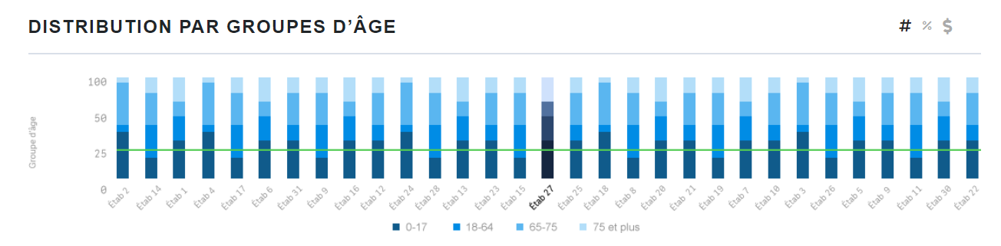

1. Groupings all except ‘Groupe d’âge’ are empty in fields (such as Gravité, Type/Atyp, Type de soins), is that due to test data?

The fields are not empty,

Gravite’ (look at fields Ref_DRGGravity.Code and Ref_DRGGravity.Description)

Type/Atyp (Ref_AtypicalPatient.Code and Ref_AtypicalPatient.Description)

Type de soin (look at fields Ref_EpisodeOfCare.Code and Ref_EpisodeOfCare.Description)